Click on the images below to replay each of the panel discussions
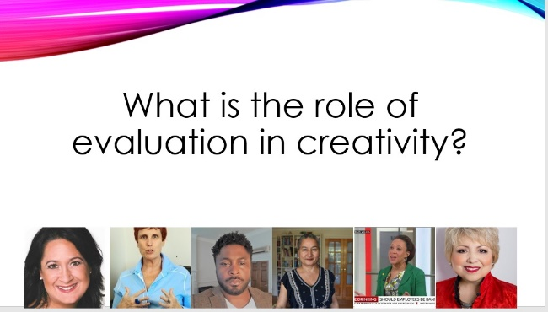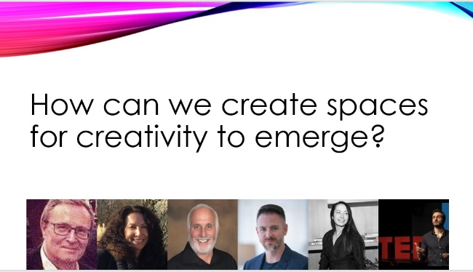
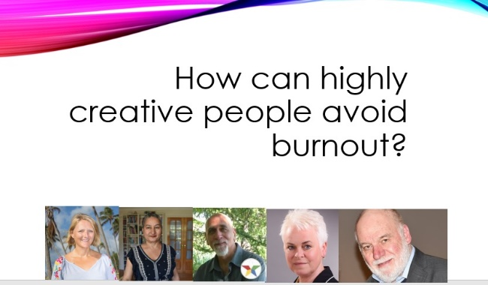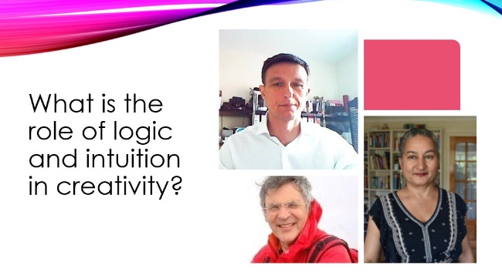
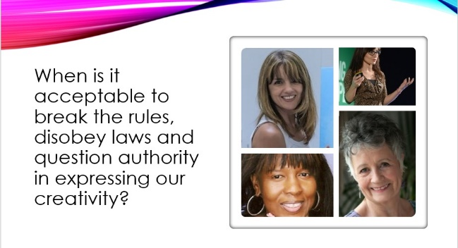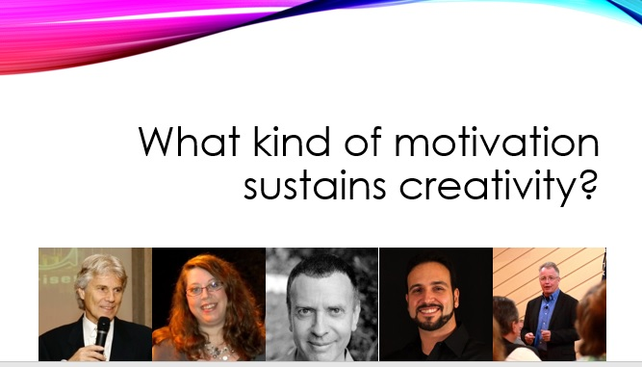

Conference Programme Saturday 22 September 2018
Time  (London, UK) | Interviews and Live Panel Discussions
9 am | Welcome by  Dr Jesvir Mahil | 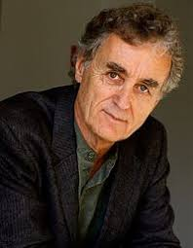  9:10: Interview: ~  Prof Fritjof Capra  How is creativity seen from a systems view?
10am  to  2pm | Interviews  10:00: Dimis Michaelides  What is the relationship between creativity and innovation?  10:15: Mok O’Keeffe  How important are constraints, limitations and knowledge of the rules, in expressing creativity?  10:30: Lindsay Milner  What is the difference between being productive and being creative?  10:45: David Chislett  How is artificial intelligence forcing us to be more creative?  11:00: Francis Newman  Is creativity a gift, a talent or a skill that can be developed like literacy and numeracy?  11:15: Dr Lalitaa Suglani  How is creativity different from mere self-expression?  11:30: Mindy Gibbins-Klein  What is the role of gatekeepers such as publishers, in evaluating creativity?  11:45: Paul Z Jackson  How important is accomplishment and achievement in creativity?  12:00: Jo Parfitt  How can we discover our creative voice in writing fiction and non-fiction?  12:15: Christopher Babayode  How important is sleep and nutrition in stimulating creativity?  12:30: Dr Howard Esbin  How does imagination influence leadership?  12:45: Graham Price  How can we change our mindset to be more creative?  13:00: Jenny Garrett  How does nature provide useful metaphors for stimulating creativity?  13:15: Dr Matt Pritchard  How is curiosity related to educational success and creativity?  13:30: Alessia Berti  How is the role of a coach important in generating creativity?  13:45: Irina Mishina  What is the connection between consciousness and creativity?
2:30pm  to  7pm | Interviews  14:30: Paulina Larocca  How do questions stimulate creativity?  14:45: Dino Gane-Palmer  How can we generate entrepreneurial creativity by distinguishing between what is possible now that was not possible before?  15:00: Dr Irena Yashin-Shaw  How do experts and novices solve problems differently?  15:15: Barbara Wilson  How useful is positive psychology in sustaining creativity?  15:30: Bob Griffiths  What is the role of internal and external critics in accurately evaluating creativity?  15:45: Callie di Nello  How important is playfulness and laughter in stimulating creativity?  16:00: Kath Dutton  How does meditation facilitate creativity?  16:15: Peter Griffiths  How important is positive social evaluation in creativity?  16:30: Sandra Cavanaugh  How feasible is it to develop creativity through spontaneity and improvisation in formal education?  16:45: Paul Rosenberg  How does humour create a space for creativity?  17:00: Kenny Mammarella D’Cruz  What is the role of unconscious architypes in manifesting creativity?  17:15: Tia Castagno  When do we need to be alone and when do we need to be collaborating with others during the creativity process?  17:30: Tom Evans  How can we harness the power of our consciousness in generating creativity?  17:45: Johanna de Ruyter  How can we use our body and movement to trigger creativity?  18:00: Hari Kalymnios  How important is sleep in generating creativity?  18:15: Hannah Adler  How does creativity in one area of our life, have an impact on other areas of our life?  18:30: Jenny Bracelin  What is the impact of metaphors we use to express our deep-seated beliefs, in generating creativity?  18:45: Dr Alan Yu  What is the Balinese approach to creativity?
7:30pm | Interviews  19:30: Ann Andrews  How can stories help to shift our perspective and energy?  19:45: Olga Kostrova  What can we do to allow creativity to flow through us, transcending the mind?  20:00: Dr Jasmine Pradissitto  How can we creatively synthesise art and science?  20:15: Glen Tucker  What is the relationship between synchronicity, serendipity, symbology and creativity?  20:30: Kat Byles  What do we need to know about creativity, to avoid burnout?
Conference Programme Sunday 23 September 2018
Time  (London, UK) | Interviews and Live Panel Discussions
9 am | 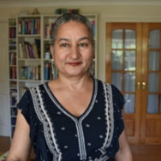  Welcome by  Dr Jesvir Mahil | 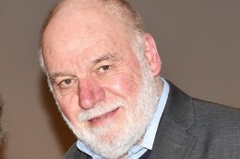  Chris Vaughan interview:  “How can we elicit creative ideas?”
10am to 2pm | 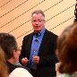  Interviews  10:00: Michelle James  To what extent can diversity in teams lead to creative emergence?  10:15: Kit Showande  How do we train young people to distinguish between recklessness and risk-taking in expressing creativity in the workplace?  10:30: Bob Eckert  How do we promote ethical expression of creativity?  10:45: Olivia Hepburn  How can we train young people to express their creativity using ethical and sustainable strategies?  11:00: Phil Shepherd  How effective is lateral thinking in stimulating creativity?  11:15: Nausherwan Akram  What are the differences in the discourse around creativity in established and emerging economies?  11:30: Christine Kimberley  How is creativity related to survival skills?  11:45: Geoff Petty  How can we overcome the challenges of limited time and resources when teaching creativity in formal, state funded education?  12:00: Jonny Wright  How well do we teach creativity in subjects such as mathematics?  12:15: Khorshed Bhote  What would be the advantages of experienced educators engaging in academic research?  12:30: Dannie-Lu Carr  How can we attract investment for creative projects that may not produce tangible benefits?  12:45: Lucy McCarraher  How important is packaging of our creativity in being successfully persuasive?  13:00: Guilherme Sarkis  How important is intrinsic motivation in driving our expression of creativity?  13:15: Grant Leboff  How important is the skill of persuasion in creativity?  13:30: Sam Reader  To what extent is creativity built upon destruction?  13:45: James Sinclair  What is the societal value of creative art?
2:30pm  to  7pm | Interviews  14:30: Jan Vermeiren  How is creativity expressed at different levels of consciousness?  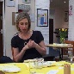  14:45: Talmud Bah  What is the relationship between diversity and creativity?  15:00: Susan Popoola  How can organisations promote creativity through effective team dynamics?  15:15: Dr Anita Pickerden  How can we express our creativity more persuasively to get past gatekeepers in recruitment & selection processes?  15:30: Laura Barbero-Switalski  How important is the physical environment for stimulating creativity?  15:45: Prith Biant  What are the differences between public and private sector organisations in allowing spaces for creativity to emerge?  16:00: Rae Luskin  Who determines the value of creativity in art?  16:15: Steve Roche  Why is there so little interest in development of creativity skills, in state funded compulsory education in the UK?  16:30: Aradhya Jharnad  What is the difference between teacher-student relationships based on Western and Confucian philosophy, in generating creativity?  16:45: Berenika Bratny  How can emotional and spiritual connection with horses inspire creativity?  17:00: Bosko Popovic  How can creativity help us to heal naturally?  17:15: Clare Louise  How can artists express their creativity through entrepreneurship?  17:30 Lorna Prescott  How can creativity strengthen community cohesion?  17:45: Dr Jose Aguilar  How does travelling, and living far away from the place of our birth, influence our expression of creativity?  18:00: Dr Michael Bloomfield  How is creativity integral to our cultural evolution?  18:15: Dr Tracy Stanley  How can we deal with the dark forces of the unconscious when expressing our creativity?  18:30: Susan Sharp  How can we discover our most unique expression of creativity?  18:45: Harj Sandher  How important is family and community support in sustaining entrepreneurial creativity?
7:30pm  to  9pm | Interviews  19:30: Dr Eric Shiu  Why is it much easier to secure funding for innovation rather than creativity?  19:45: Orlando McDonald  What do entrepreneurs mean when they say that they have “created something from nothing”?  20:00: Brian Marcel  What sustains creative leadership in business?  20:15: Pirjo Suhonen  How does the Finnish education system empower teachers and students to develop creativity skills?  20:30: Terry Tillman  In what way are “How to…..” strategies counterproductive in generating creativity?  20:45: Dr Jesvir Mahil  How can digital stories be used for creative cultural transformation?

